**LAB X - Part 1**

Create this drum sampler using the file “LabX - Part 1 - DEMO.maxpat”.

**Due: turn in a screenshot of your finished patch and name it as follows: “lastname firstname lab X part 1”. Please also include a comment with your name in the patch.**

Lab X Part 1 Video link:

Follow the video demonstration and the extensive comments within the patch to guide you to make the patch pictured below.

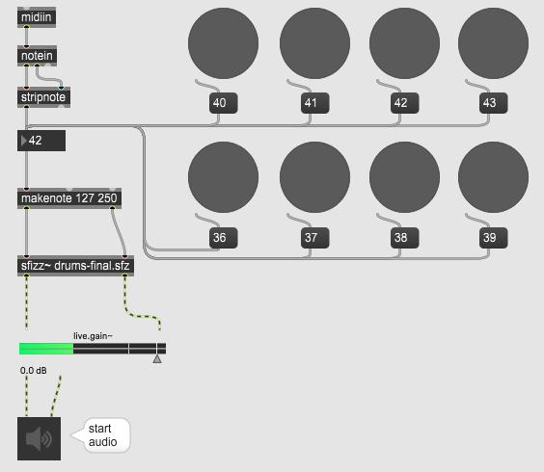

**LAB 6 - Part 2**

Create this clarinet multi-sampler using the file “LabX - Part 2 - DEMO.maxpat”.

**Due: turn in a screenshot of your finished patch and name it as follows: “lastname firstname lab X part 2”. Please also include a comment with your name in the patch.**

Lab X Part 2 Video link:

Follow the video demonstration and the extensive comments within the patch to guide you to make the patch pictured below.

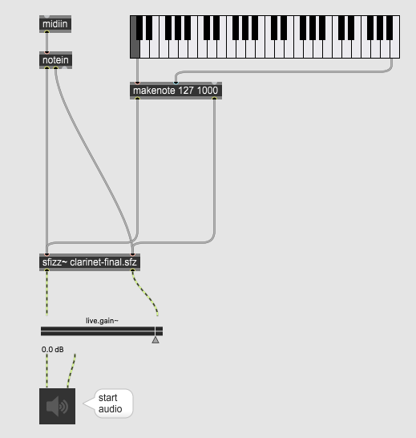

**LAB X - Part 3**

**Due: Answer the questions below and turn in the answers in a document labeled as follows : “lastname firstname lab X part 3”. Please save your document as a pdf.**

1. In our drum sampler patch, create a message box with the following without quotes: “43 127 50.” Then, connect it to the “makenote” object.
   1. What’s the resulting sound?
   2. What happens when you change the message to say “43 127 2500”?
   3. What are some of the expressive possibilities of configuring the sample to playback differently in this way?
2. What is the point of a multisampler? Why not just use one sample and change its volume when we play it back? (Hint, think about timbre)
3. Let’s say we wanted to include a medium volume sample for our multisampler for the pitch E4. The sound file is titled “ClBb-ord-E4-mf.wav”. If you were to define a region for this sample, what would the line of script look like? (Hint, what do you think a good “medium” velocity range would be?)
4. If we wanted to design a module that changes the timbre of our sample, where would we build and connect it in our patch?
5. In between the number box and “makenote”
6. In between “makenote” and “sfizz~”
7. In between “sfizz~” and “live.gain”
8. In between “live.gain” and “ezdac~”

**Push goal** - Create a lowpass filter for the drum sampler with controls for cutoff frequency and resonance. Consider using previous labs for help building a filter module. Hints:

* You might want to consider using the “svf~” object.
* For controlling the filter’s parameters, you can use dials, and sliders as normal, but maybe consider building an LFO that modulates filter parameters as well.
* Consider expanding the sampler even further by building another module such as distortion, reverb, or delay.